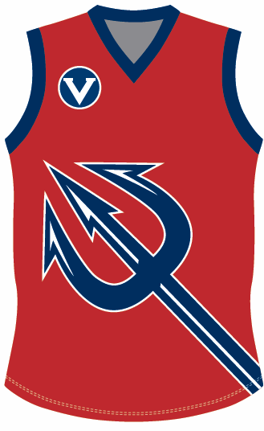

BOX HILL NORTH FOOTBALL CLUB INFO PACK

Club Info

Website: www.boxhillnorthfc.com.au

Club Email Address: info@boxhillnorthfc.com.au

Facebook Group (private): http://www.facebook.com/groups/bhnfc/
Facebook Page: https://www.facebook.com/boxhillnorthfc

Twitter: @BHNFC
YouTube: BHNFC TV

Instagram: boxhillnorthfc

League Info

League: Victorian Amateur Football Association (VAFA)

Division: 4

Senior Coach Contact Details

Name: Alan Chung

Email: alan.chung.mobile@gmail.com

Mobile: 0425 786 329

Ground Location Details

Address: Elgar Park
653-661 Elgar Road (Corner Elgar Rd& Belmore Rd)
Mont Albert North, 3129
Melways Ref: 47 C4

See Map of Home Ground Location Below:



