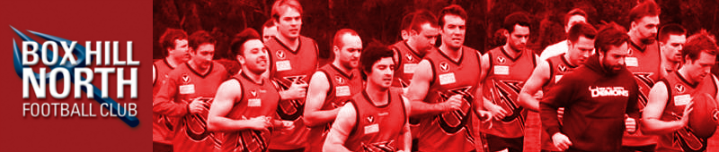SPONSORSHIP PACKAGES 2015
Major Sponsor Package - $10,000
- Sponsors logo on the back of the playing jumper.
- Sponsors logo on all new club merchandise.
- Sponsors logo on ground signage including:
  - External to the club rooms.
  - Along fence-line facing Elgar Road.
  - Scoreboard.
  - Within the social rooms.
- Advertising on all club e-mails and club letterheads.
- Framed playing jumper for display in the sponsor’s place of business.
- Framed Senior Team photograph for display in the sponsor’s place of business.
- 2 x Club Polo Shirts (or 1 x Club Polo and 1 x Club Jumper)
- 2 drink cards per home game.
- Framed BHNFC ‘certificate of appreciation’.
- Invitation to the Sponsors Lunch.
- Four tickets in the annual Reverse Raffle night.
- A reserved table for 8 people at the club’s Presentation Night.
- Prominent front page advertisement on club website, Facebook page and Twitter.
- Free entry to all club functions for 2 people.
- A hyperlink on the club website which is directed straight to the sponsor’s business.
- 2 x Social Memberships to Box Hill RSL
Any specific request by the sponsor which is not listed will be considered.

Gold Sponsorship Package - $5,000
- Sponsors logo on front of club shorts.
- Sponsors logo on ground signage including:
  - External club rooms.
  - Scoreboard.
  - Within the social rooms.
- Advertising on all club e-Mails and club letterheads
- Framed Senior Team photograph for display in the sponsor’s place of business.
- 1 x Club Polo Shirt and 1 x Club Jumper.
- 1 drink card per home game.
- Framed BHNFC ‘certificate of appreciation’.
- Two tickets in our annual Reverse Raffle night.
- Four tickets to attend the club’s Presentation Night
- Invitation to the Sponsors Lunch.
- Prominent advertisement on club website, Facebook page and Twitter
- Free entry to all club functions for 1 person.
- A Hyperlink on the club website which is directed straight to the sponsor’s business.
- 1 x Social Membership to Box Hill RSL
Any specific request by the sponsor which is not listed will be considered.
Silver Sponsorship Package - $2,000
- Sponsors logo on ground signage including:
  - External club rooms.
  - Within the social rooms.
- Framed Senior Team photograph for display in the sponsor’s place of business.
- Framed BHNFC ‘certificate of appreciation’.
- 1 x Club Polo Shirt.
- 1 drink card per home game.
- Two Tickets in our annual Reverse Raffle night.
- Two tickets to attend the club’s Presentation Night.
- Invitation to the Sponsors Lunch.
- Advertisements on club website, Facebook page and Twitter.
- A hyperlink on the club website which is directed straight to the sponsor’s business
- 1 x Social Membership to Box Hill RSL
Any specific request by the sponsor which is not listed will be considered.
Premium Player Sponsorship Package - $750
- Photograph of sponsored player with sponsor’s details boldly listed underneath and displayed in clubrooms.
- 1 x Club Polo Shirt.
- 1 drink card per home game.
- Invitation to the Sponsors Lunch.
- One ticket to attend the club’s Presentation Night.
- One ticket in our annual Reverse Raffle night.
- Framed photograph of the sponsored Player for display in the sponsor’s place of business.
- Acknowledgment on the club website and in club emails.
Player Sponsorship Package - $500
- Photograph of sponsored player with sponsor’s details boldly listed underneath and displayed in clubrooms.
- Invitation to the Sponsors Lunch.
- Framed photograph of the sponsored Player for display in the sponsor’s place of business.
- Acknowledgment on the club website and in club emails.
Coterie Club Membership - $250
- 1 x Club Polo Shirt.
- Invitation to attend the Season Launch / Jumper Presentation Night.
- One Ticket in the Annual Reverse Raffle Night
- Reduced drink prices on Thursday nights at the clubrooms ($0.50 off all drinks)
- $50.00 Drink Card OR 1 x Social Membership to Box Hill RSL
A reduction of $50.00 applies to Life Members or Premiership Players.
Custom Sponsorship Package
Potential sponsors are invited to negotiate their own sponsorships terms.

